1. Get IDs from <https://stage.eightfold.ai/internal/console/release_management?tab_id=release_management_reports>

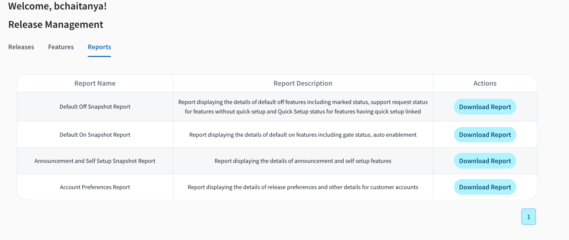PS: use account preferences report

1. Raise request on #customer-account-access
2. Run script to add permissions

python modify_perms_in_config.py --group_regex costar-sandbox.com --roles admin --permissions perm_manage_rectruitmentanalytics_dashboard --add --user bchaitanya@eightfold.ai



1. Run Script to create dataset

from quicksight import qs_data

from config import config

from utils.os_constants import EF_DEFAULT_REGION

group_ids = ['10xgenomics.com']

error_group_ids = [] # Create an empty list to store erroring group IDs

for group_id in group_ids:

db_shard_config = config.get_config_for_partition('db_group_shard_config', group_id)

try:

account_region = list(db_shard_config.keys())[0]

except:

continue

if account_region != EF_DEFAULT_REGION:

print(f"Skipping group_id {group_id} as account_region {account_region} is different from {EF_DEFAULT_REGION}")

continue

try:

handler = qs_data.QuicksightDataHandler(group_id)

registry = handler.get_dataset_provisioning_registry()

registry["ta_feature_campaign_application_activity"]["create"]()

except Exception as e: # Catch any exceptions (more specific than just Exception)

print(f"Error creating dataset setup for group ID '{group_id}': {e}")

error_group_ids.append(group_id)



1. Run script update dashboard

from quicksight import qs_dashboards

from config import config

from utils.os_constants import EF_DEFAULT_REGION

dashboard_key = 'tafeatureusage'

group_ids = ['10xgenomics.com']

error_group_ids = [] # Create an empty list to store erroring group IDs

for group_id in group_ids:

db_shard_config = config.get_config_for_partition('db_group_shard_config', group_id)

try:

account_region = list(db_shard_config.keys())[0]

except:

continue

if account_region != EF_DEFAULT_REGION:

print(f"Skipping group_id {group_id} as account_region {account_region} is different from {EF_DEFAULT_REGION}")

continue

try:

handler = qs_dashboards.QuicksightDashboardHandler(group_id)

handler.create_dashboard_setup(dashboard_key)

except Exception as e: # Catch any exceptions (more specific than just Exception)

print(f"Error creating dashboard setup for group ID '{group_id}': {e}")

error_group_ids.append(group_id)

